Saint Luis University Madrid

Class: CSCI-2300

Instructor: Javier Gamo

Members: Nick Markunas, Jan Lutter, Josh Kuroda

**Project #2 – Documentation**

**Driver Class:**

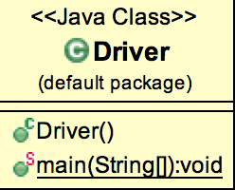

* public class Driver
* extends java.lang.Object

### Constructor Summary

|  |
| --- |
| Constructors |
| **Constructor and Description** |
| Driver() |

### Method Summary

|  |  |
| --- | --- |
| **Modifier and Type** | **Method and Description** |
| static void | main(java.lang.String[] argv) |

### Methods inherited from class java.lang.Object

equals, getClass, hashCode, notify, notifyAll, toString, wait, wait, wait

### Constructor Detail

#### Driver

public Driver()

### Method Detail

#### main

* + - public static void main(java.lang.String[] argv)
    - throws javax.xml.xpath.XPathExpressionException,
    - javax.xml.transform.TransformerConfigurationException,
    - org.xml.sax.SAXException,
    - java.io.IOException,

javax.xml.parsers.ParserConfigurationException

Throws:

javax.xml.xpath.XPathExpressionException

javax.xml.transform.TransformerConfigurationException

org.xml.sax.SAXException

java.io.IOException

javax.xml.parsers.ParserConfigurationException

**Handler Class:**

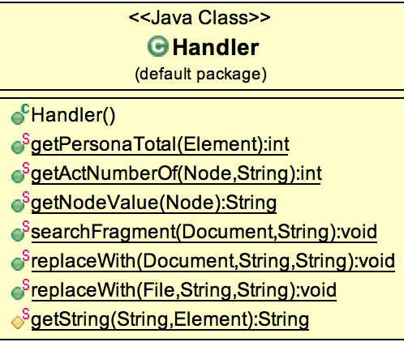

## Class Handler

* java.lang.Object
  + Handler

public class Handler

extends java.lang.Object

### Constructor Summary

|  |
| --- |
| Constructors |
| **Constructor and Description** |
| Handler() |

### Method Summary

|  |  |
| --- | --- |
| **Modifier and Type** | **Method and Description** |
| static int | getActNumberOf(org.w3c.dom.Node root, java.lang.String character) |
| static java.lang.String | getNodeValue(org.w3c.dom.Node node) |
| static int | getPersonaTotal(org.w3c.dom.Element root) |
| static void | replaceWith(org.w3c.dom.Document doc, java.lang.String fragment, java.lang.String alt) |
| static void | replaceWith(java.io.File xml, java.lang.String fragment, java.lang.String alt) |
| static void | searchFragment(org.w3c.dom.Document doc, java.lang.String fragment) |

### Methods inherited from class java.lang.Object

equals, getClass, hashCode, notify, notifyAll, toString, wait, wait, wait

### Constructor Detail

#### Handler

public Handler()

### Method Detail

#### getPersonaTotal

public static int getPersonaTotal(org.w3c.dom.Element root)

#### getActNumberOf

* + - public static int getActNumberOf(org.w3c.dom.Node root,

java.lang.String character)

#### getNodeValue

public static java.lang.String getNodeValue(org.w3c.dom.Node node)

#### searchFragment

* + - public static void searchFragment(org.w3c.dom.Document doc,
    - java.lang.String fragment)
    - throws javax.xml.transform.TransformerConfigurationException,

javax.xml.xpath.XPathExpressionException

Throws:

javax.xml.transform.TransformerConfigurationException

javax.xml.xpath.XPathExpressionException

#### replaceWith

* + - public static void replaceWith(org.w3c.dom.Document doc,
    - java.lang.String fragment,
    - java.lang.String alt)
    - throws java.io.IOException,
    - org.xml.sax.SAXException,
    - javax.xml.xpath.XPathExpressionException,
    - javax.xml.transform.TransformerConfigurationException,
    - javax.xml.transform.TransformerException,

javax.xml.parsers.ParserConfigurationException

Throws:

java.io.IOException

org.xml.sax.SAXException

javax.xml.xpath.XPathExpressionException

javax.xml.transform.TransformerConfigurationException

javax.xml.transform.TransformerException

javax.xml.parsers.ParserConfigurationException

#### replaceWith

* + - public static void replaceWith(java.io.File xml,
    - java.lang.String fragment,
    - java.lang.String alt)
    - throws java.io.IOException,
    - javax.xml.parsers.ParserConfigurationException,
    - org.xml.sax.SAXException,

javax.xml.xpath.XPathExpressionException

Throws:

java.io.IOException

javax.xml.parsers.ParserConfigurationException

org.xml.sax.SAXException

javax.xml.xpath.XPathExpressionException